A Project Report on

**College Network Scenario**

Submitted fulfillment of the requirements of the Semester III Subject of

**Data Communication and Networking Lab**

in

**Information Technology**

By

**Muhammad Ibrahim (01-135231-062)**

**M Abdullah Bin Abdul Aziz (01-135231-043)**

**Muhammad Ali Qureshi (01-135222-012)**

**Section BS-IT 3-B**

Subject In-charge

**Malik Umair Sajjad**



**Department of Information Technology**

Bahria University Islamabad, E-8 campus

Table of Contents

Introduction 4

Objectives 4

Network Requirements 4

Existing Infrastructure 5

Network Devices 5

Therory Deliverables 7

IP schemes: 7

1. Selection of Network IP Blocks: 7

2. Subnetting: 7

3. Departmental Network Addresses 7

4. Server Room Subnet: 8

5. Principal Room Subnet: 8

6. Additional Considerations: 8

Methodology – Network diagrams 8

Accesing webpage(Bahria.com) from a host 11

Difficulties faced in project implementation: 12

Lap Deliverables 12

Implementation of RIP between different routers: 14

VLANs on Local Area Network: 15

Implementation of TFTP server 16

Subnetting 17

Summary 21

***Abbreviations***

|  |  |
| --- | --- |
|  |  |
| **MSE** | **M**obility **S**ervice **E**ngine |
| **UCS** | **U**nified **C**omputing **S**ystem |
| **RFP** | **R**equest **F**or **P**roposal |
| **IP** | **I**nternet **P**rotocol |
| **RIP** | **R**outing **I**nformation **P**rotocol |
| **RPP** | **R**outing **P**rotocol **P**lan |
| **OS** | **O**perating **S**ystem |
| **OSI** | **O**pen **S**ystems **I**nterconnection |
| **FTP** | **F**ile **T**ransfer **P**rotocol |
| **DNS** | **D**omain **N**ame **S**ystem |
| **LAN** | **L**ocal **A**rea **N**etwork |
| **VLAN** | **V**irtual **L**ocal **A**rea **N**etwork |

# Introduction

This College Network Scenario is about designing a topology of a network that is a LAN (Local Area Network) for a College in which various computers of different departments are set up so that they can interact and communicate with each other by interchanging data. To design a networking scenario for a college which connect various departments to each other’s, it puts forward communication among different departments. CNS is used to design a systematic and well-planned topology, satisfying all the necessities of the college (i.e. client). CNS come up with a network with good performance.

# Objectives

The main objective of the proposed network is to update the existing network and also enhance its capabilities and increase the flexibility of the network which will eventually provide good security.

# Network Requirements

1: The new system should be able to reduce internet downtime. Download and upload links should be maintained above 5 Mbps speed requirement.

2: Network will be scalable.

3: The system should support remote access.

4: Should comprise of data centers with necessary security features and support.

# Existing Infrastructure

The existing system is a very basic system. College mainly comprises of three main sections as

1. TPO & Other
2. Exam Center 3. Office

All the hosts are assigned with static IPs and are assigned in the order in which it where set up. No support for dynamic IP allocations. Even though the working is divided into three major sectors all the host, multimedia devices are connected in a single network. Thus, network security and maintenance are difficult. One more problem observed was the existing switches were outdated and hence could not prove to be beneficial for the network administrator to observe monitor and handle the network traffic the system has no remote access to the network. Absence of basic small-scale businesses firewall was also observed. Thus, security is also compromised. Three server rooms were used for the purpose of independent networking which further caused wastage of power and money.

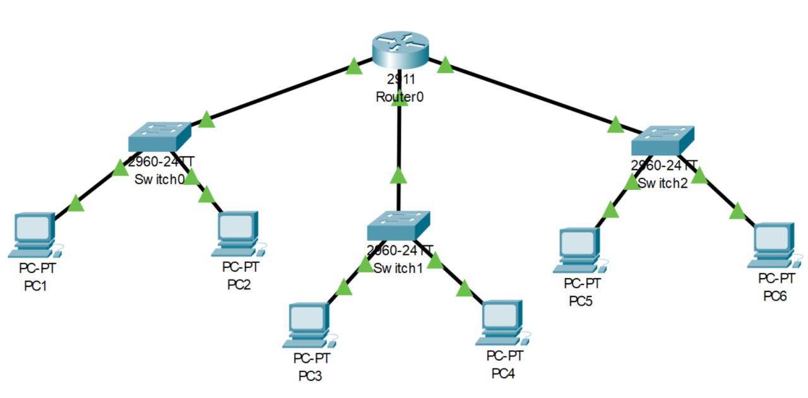

*The above design is the existing network traced on cisco packet tracer.*

# Network Devices

Developing the existing Lan system:

* The basis of the LAN core is Cisco Catalyst 6509 switches equipped with Cisco 720 supervisors and Virtual Switching System (VSS), as well as Cisco 4500 switches, combined in a stack with the data transmission ports at 10 Gb/s bandwidth capacity. Switches create a platform for additional services, such as content processing, firewall (the project uses the Cisco firewall), intrusion prevention system, application of IPsec security tools, the arrangement of protected VPN channels, network analysis and acceleration of Secure Sockets Layer (SSL) connections.

Mobility Services Engine (MSE) solution and 300 Cisco Aironet 1140 access points were used.

* The Cisco Aironet 1140 Series is a component of the Cisco Unified Wireless Network, which can scale up to 18,000 [access points](https://www.cisco.com/en/US/products/ps5678/Products_Sub_Category_Home.html) with full Layer 3 mobility across central or remote locations on the enterprise campus, in branch offices, and at remote sites.

* The Cisco Unified Wireless Network is the industry’s most flexible, resilient, and scalable architecture, delivering secure access to mobility services and applications and offering the lowest total cost of ownership and investment protection by integrating seamlessly with the existing wired network.

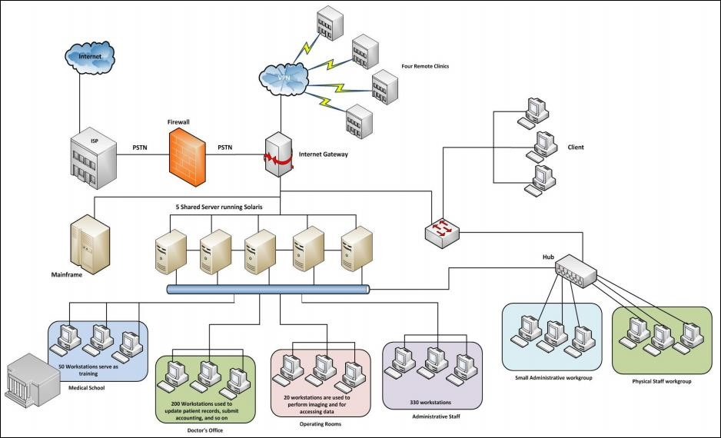

*Above is the pictorial representation of the proposed network*

Cisco Unified Computing System (UCS) solution allowed the integration of computer and network resources as well as storage and virtualization systems as part of an energy efficiency system. Cisco Unified Computing System platform notably simplifies traditional architecture and significantly reduces the number of devices to be purchased, to connect by wires, to supply with electricity and cooling, to protect and maintain. This solution is the foundation of complex optimization of the virtualized medium while maintaining the ability to support traditional operating systems and applications stacks in physical medium. This overall infrastructure developed allowed integration of several functionally different physical networks into one, such as guest network, hotel management network, telephone network and IP-Television network. The convergence within single network reduced hotel expenses for constructing and managing several dedicated networks which traditionally remain separate in hotels.

The term unified computing system is often associated with Cisco. Cisco UCS products have the ability to support traditional operating system ([OS)](https://whatis.techtarget.com/definition/operating-system-OS) and application stacks in physical environments, but are optimized for [virtualized](https://searchservervirtualization.techtarget.com/definition/virtualization) environments. Everything is managed through Cisco UCS Manager, a software application that allows administrators to provision the server, storage and network resources all at once from a [single pane of glass.](https://searchconvergedinfrastructure.techtarget.com/definition/single-pane-of-glass) Similar offerings to Cisco UCS include HP BladeSystem Matrix, Liquid Computing's LiquidIQ, Sun Modular Datacenter and InteliCloud 360.

Therory Deliverables:

# IP schemes:

# 1. Selection of Network IP Blocks:

* Private IP Blocks: The network primarily uses private IP blocks (192.168.0.0/16, 128.168.0.0/16), appropriate for internal networks and avoiding conflicts with public addresses.
* Public IP Block Usage (1.0.0.0/8): The "Server Room" subnet uses a public IP block.

# 2. Subnetting:

* The network is divided into subnets based on departments and functions, promoting better organization, security, and traffic management.
* Subnet masks are likely /24, allowing up to 254 devices per subnet, generally sufficient for the current needs.

3. Departmental Network Addresses:

* Department-Specific Subnets: Each department has a dedicated subnet, isolating traffic, improving security, and simplifying administration.
* DHCP for Specific Subnets: DHCP is used for dynamic IP assignment in the Administration subnet and for wireless devices in the Chemical and Aero Departments, streamlining management.

# 4. Server Room Subnet:

* Separate Subnet: Isolating servers in a distinct subnet enhances security and control over server resources.
* Recommendation: Use a private IP block (e.g., 10.0.0.0/8) for better alignment with internal network practices.

# 5. Principal Room Subnet:

* Isolation: Separating the Principal's devices into a dedicated subnet safeguards privacy and security.

# 6. Additional Considerations:

* Network Size: If the network expands significantly, consider a larger private IP block (e.g., 10.0.0.0/8) for more flexibility.
* Security: Implement firewalls and access control lists to reinforce security between subnets and protect sensitive data.
* Network Growth: Leave unused IP addresses in each subnet to accommodate future expansion.

# Methodology – Network diagrams

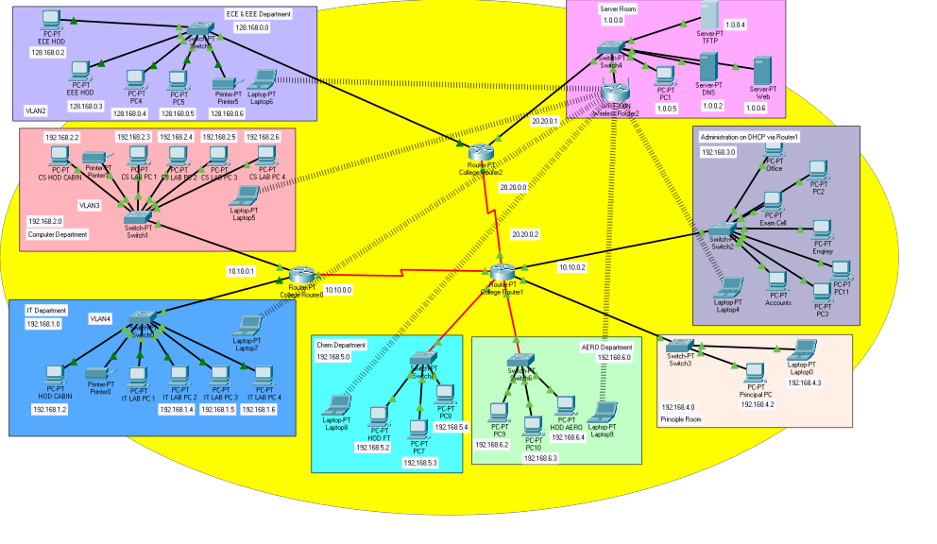

**ECE dept**:

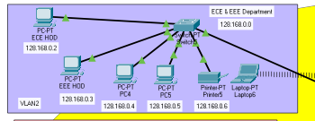

**Computer Dept**:

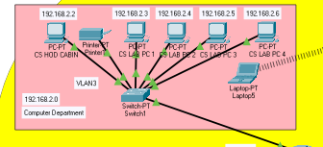

**IT Dept:**

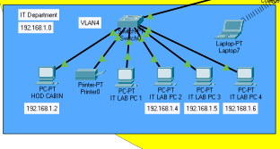

**Aero dept:**

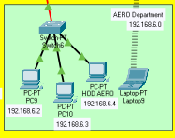

**Chem Dept:**

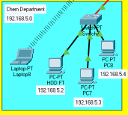

**Administration:**

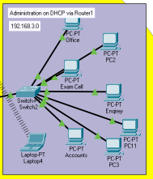

**Server room:**

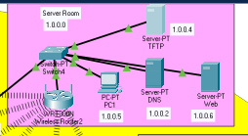

**Ping from Chem dept to Aero dept:**

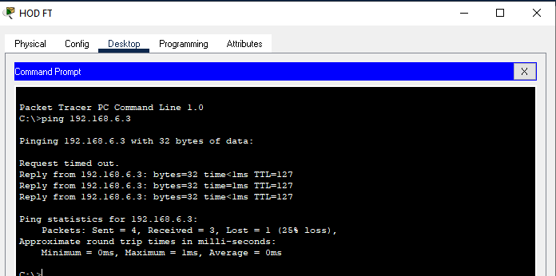

Accesing webpage(Bahria.com) from a host**:**

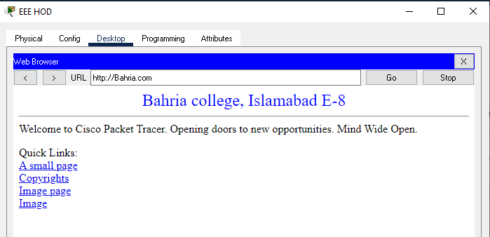

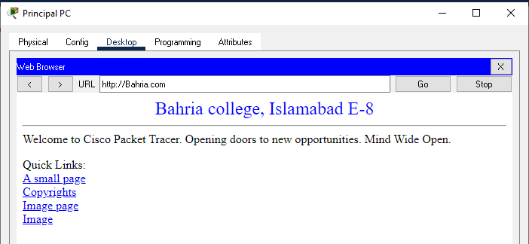

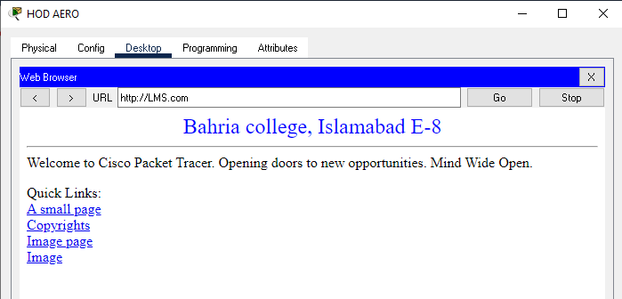

# Difficulties faced in project implementation:

During the project implementation phase, one significant challenge was unexpected technical complexities that arose during the making of this project. The team encountered unanticipated compatibility issues between the existing infrastructure and the newly implemented software, leading to delays and disruptions in the project timeline. Additionally, communication breakdowns among team members added another layer of complexity, hindering the resolution of these technical challenges. To mitigate these difficulties, the project manager implemented an intensive training program to enhance the team's technical skills and foster better collaboration. Additionally, a more robust communication plan was put in place to ensure that issues were promptly addressed and that all team members were aligned with the evolving project requirements. Despite these challenges, the project team successfully navigated through the difficulties, demonstrating adaptability and resilience in the face of unexpected obstacles.

Top of Form

# Lap Deliverables

**Configuration of Hosts and DHCP:**

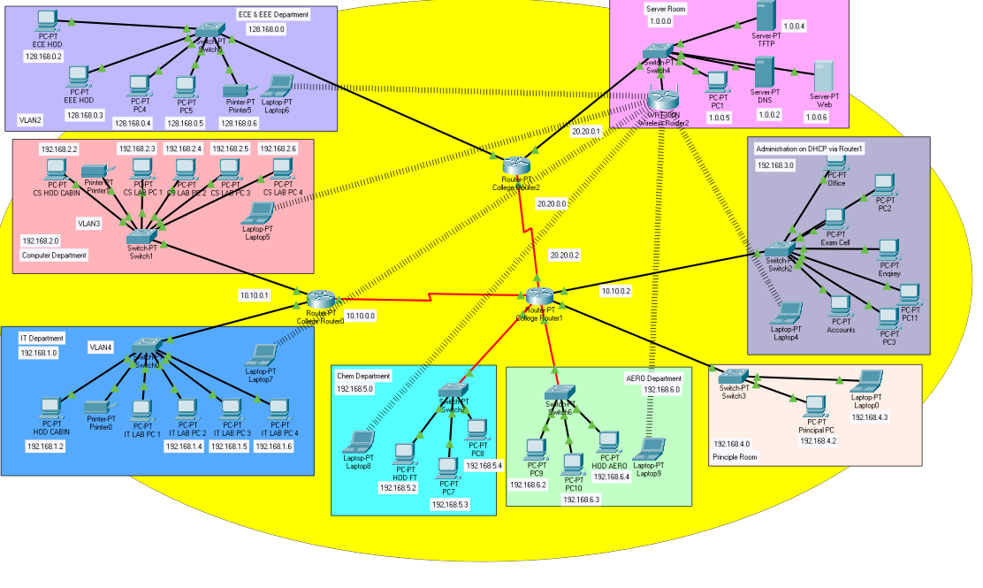

As you can see all the host have been configured and labelled.

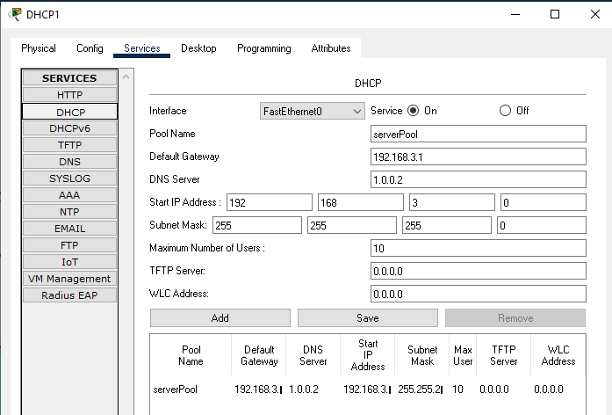

A DHCP server applies DHCP configuration to **Administration Department** via DHCP1 as you can see above.

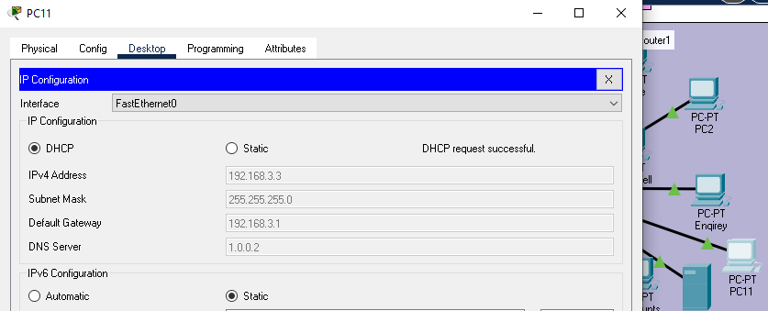

* **Another DHCP(dhcp2) is added in FT dept:**

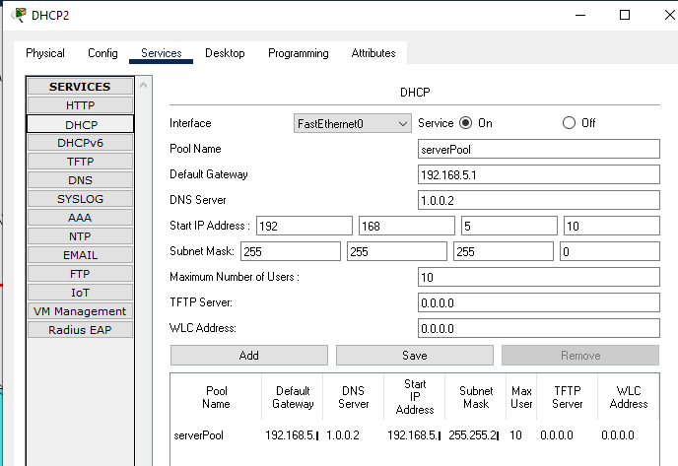

**Sending request to check:**

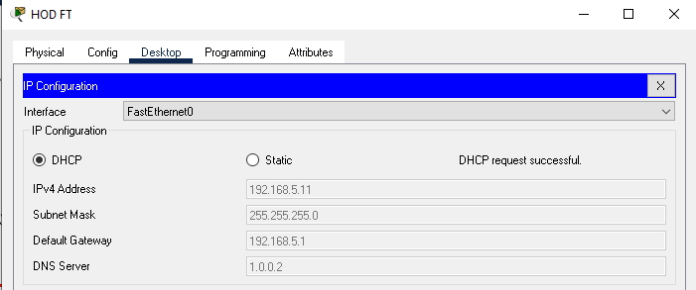

As you can see above we have successfully acquired IP address by DHCP request and the same goes for the rest of the Host in that department.

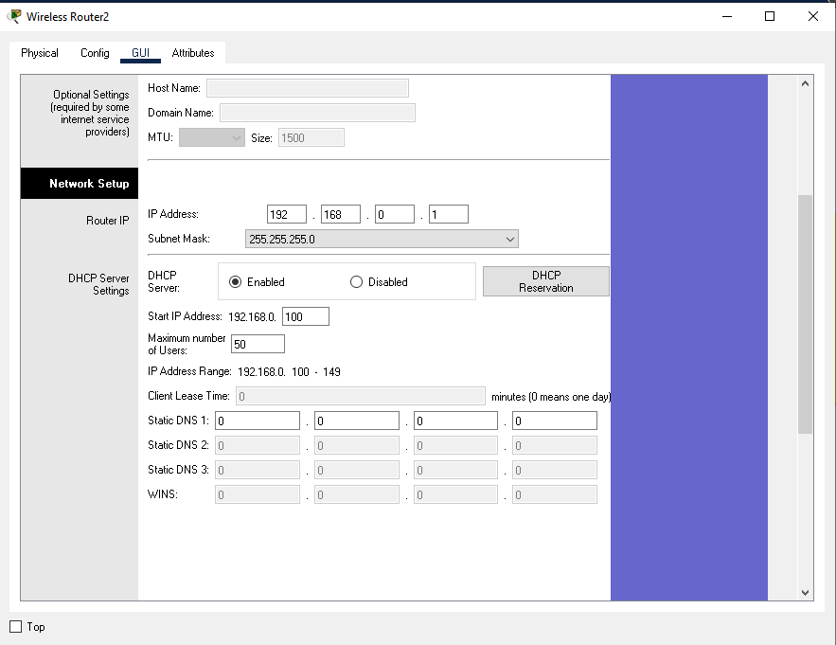

*Configuration for wireless router for DHCP*

# Implementation of RIP between different routers:

Routing Information Protocol (RIP) is a dynamic routing protocol which uses hop count as a routing metric to find the best path between the source and the destination network. It is a distance vector routing protocol which has AD value 120 and works on the application layer of OSI model.

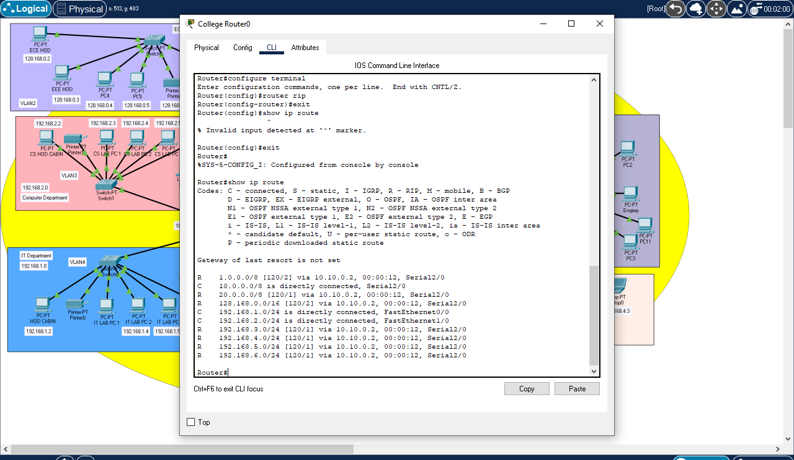

*Routing Protocol Plan for Router0*

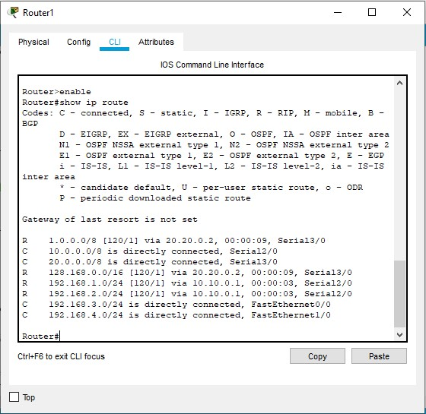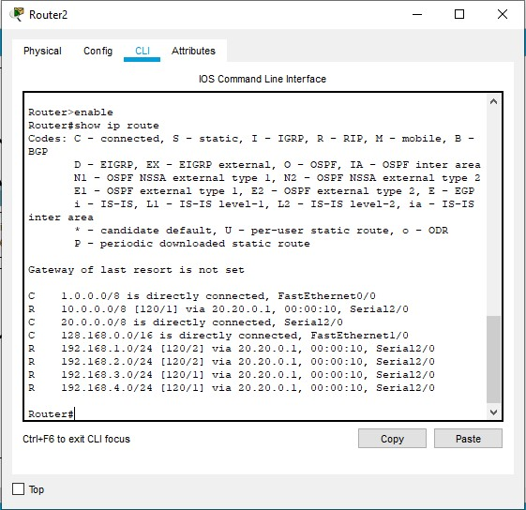

*Routing Protocol Plan for collegeRouter1 Routing Protocol Plan for collegeRouter2*

# VLANs on Local Area Network:

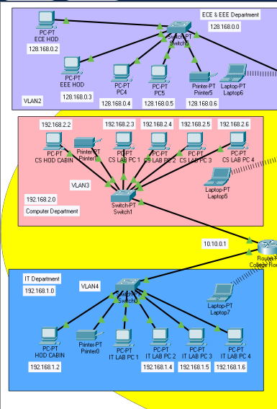

Three depts IT dept, Computer dept and ECE dept have been configured on VLAN 4, VLAN3 and VLAN 2 respectively see image above.

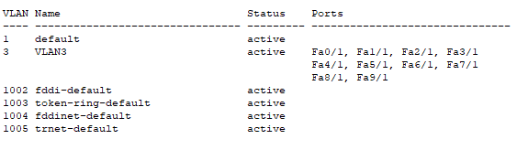

*VLAN is active for computer dept and same for others see below*

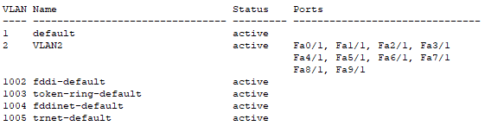

*For ECE dept*

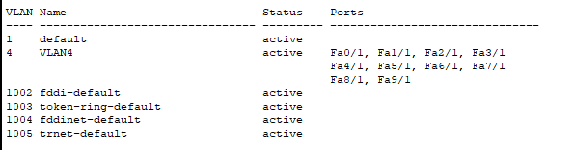

*For IT dept*

# Implementation of TFTP server

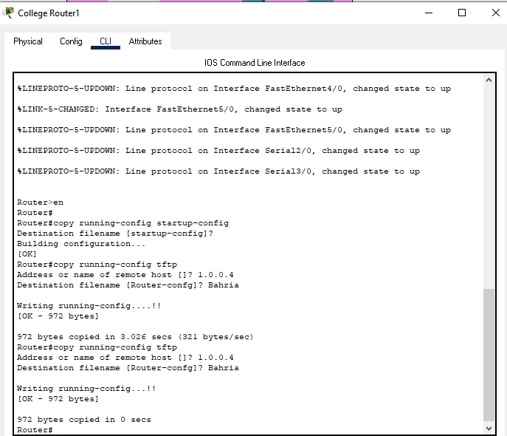

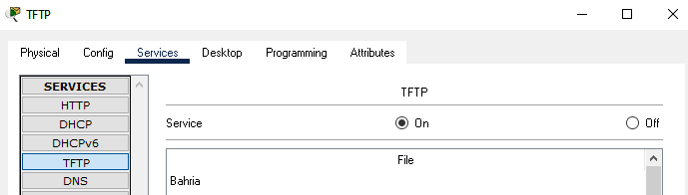

# Subnetting

Subnetting is a technique used in computer networking to divide a large IP network into smaller, more manageable sub-networks, or subnets. The main purposes of subnetting are to improve network performance, enhance security, and facilitate efficient use of IP addresses. Subnetting is a crucial aspect of IP address management, particularly in large networks.

And the subnetting for this project is:

|  |  |
| --- | --- |
| **IT DEPARTMENT (192.168.1.0)** | |
| HOD CABIN | 192.168.1.2 |
| IT LAB 1 | 192.168.1.3 |
| IT LAB 2 | 192.168.1.4 |
| IT LAB 3 | 192.168.1.5 |
| IT LAB 4 | 192.168.1.6 |
| Printer 0 | 192.168.1.7 |

|  |  |
| --- | --- |
| **COMPUTER DEPARTMENT (192.168.2.0)** | |
| CS HOD CABIN | 192.168.2.2 |
| CS LAB 1 | 192.168.2.3 |
| CS LAB 2 | 192.168.2.4 |
| CS LAB 3 | 192.168.2.5 |
| CS LAB 4 | 192.168.2.6 |
| Printer 7 | 192.168.2.7 |

|  |  |
| --- | --- |
| **Administration (192.168.3.0) on DHCP(192.168.3.10 and onwards)** | |
| OFFICE | 192.168.3.2 |
| Printer 2 | 192.168.3.6 |
| EXAM CELL | 192.168.3.3 |
| PC3 | DHCP |
| ENQUIRY | DHCP |
| Laptop4 | DHCP |
| Printer 4 | DHCP |

|  |  |
| --- | --- |
| **SERVER ROOM (1.0.0.0)** | |
| TFTP SERVER | 1.0.0.4 |
| PC1 | 1.0.0.5 |
| DNS SERVER | 1.0.0.2 |
| WEB SERVER | 1.0.0.3 |

|  |  |
| --- | --- |
| **ECE DEpartment(128.168.0.0)** | |
| ECE HOD | 128.168.0.2 |
| PC3 | 128.168.0.3 |
| PC4 | 128.168.0.4 |
| PC5 | 128.168.0.5 |
| Printer 5 | 128.168.0.6 |

|  |  |
| --- | --- |
| **PRINCIPLE ROOM (192.168.4.0)** | |
| PC 0 | 192.168.4.2 |
| LAPTOP 0 | 192.168.4.3 |

|  |  |
| --- | --- |
| **Chemical Department (192.168.5.0)** | |
| HOD | 192.168.5.2 |
| PC1 | 192.168.5.3 |
| PC2 | 192.168.5.4 |
| PC chem1 | 192.168.5.2 |
| Laptop | DHCP Via wireless router |

|  |  |
| --- | --- |
| **Aero Department (192.168.6.0)** | |
| PC 9 | 192.168.6.2 |
| PC 10 | 192.168.6.3 |
| HOD Aero | 192.168.6.4 |
| Laptop | DHCP via wireless router |

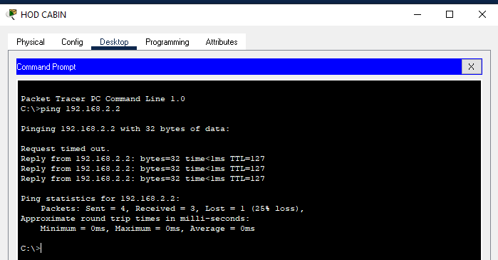

*Testing VLAN communications from HOD Cabin to Computer Dept*

# Summary

The outcome of the proposed system will be a fail-safe backbone network infrastructure which meets the requirements for readily available access to information and security of the private network, and also ensures optimized productivity when telecommunication services are accessed. The installed equipment allowed to organize high-speed wired and wireless Internet access throughout the whole complex of hospital buildings as well as providing transfer of all types of data throughout the single optimized network.